**Introduction of Tools and their setup for SFDX.**

Step 1 : Download and Install Visual studio code program.

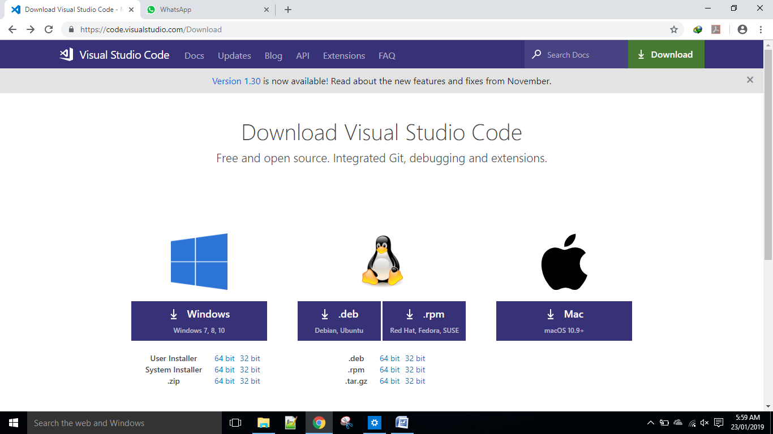

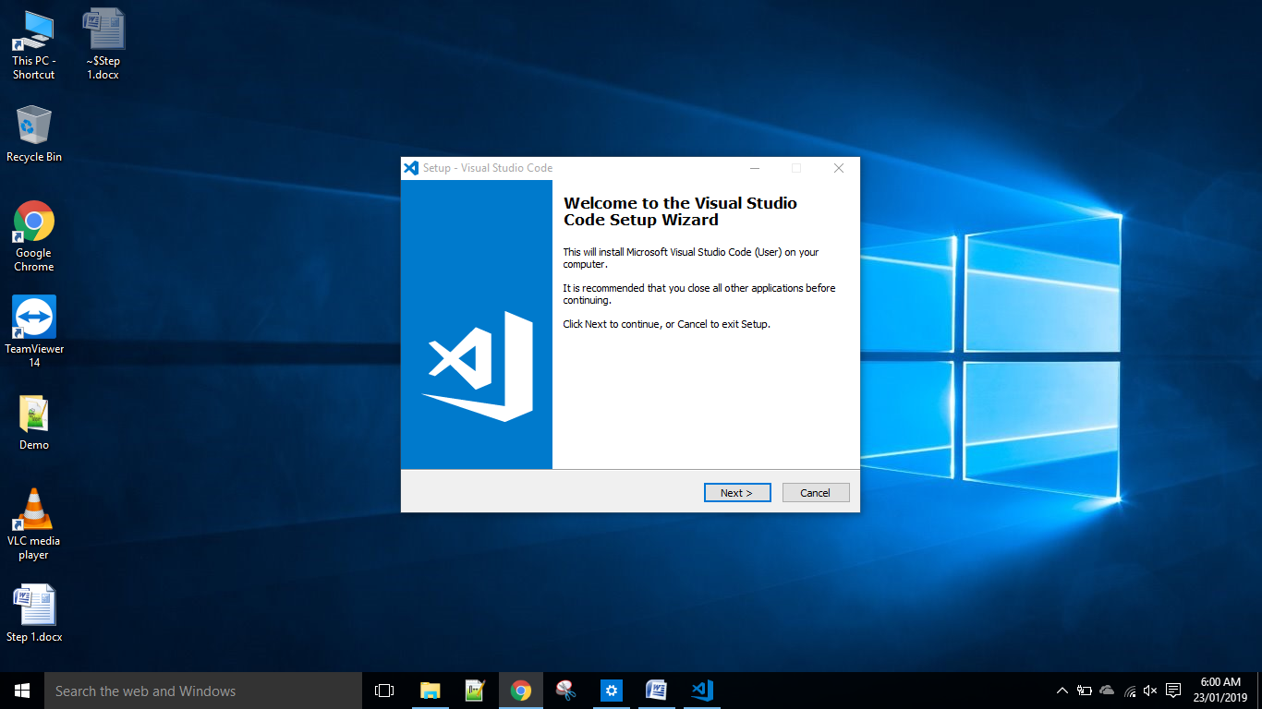

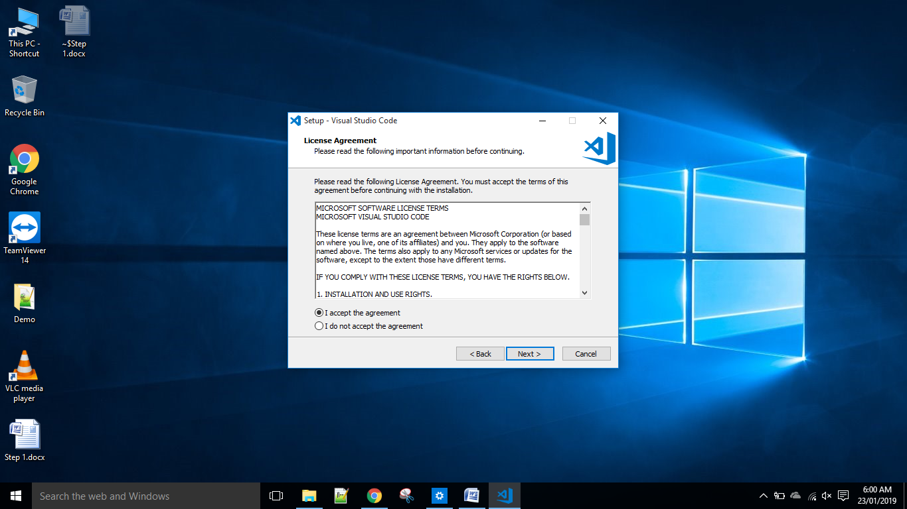

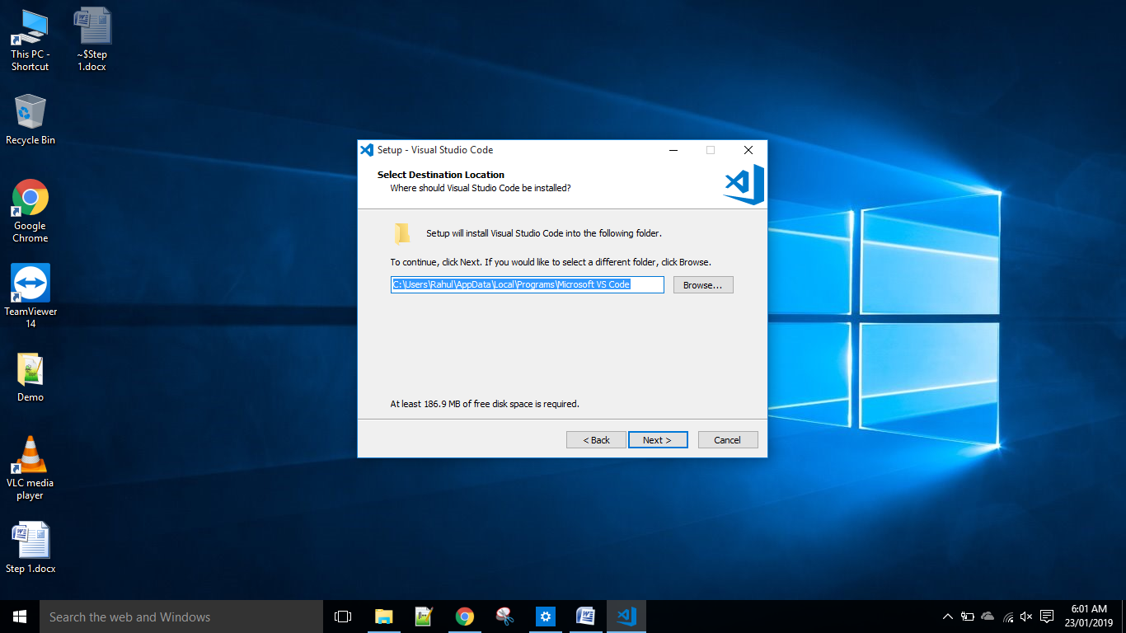

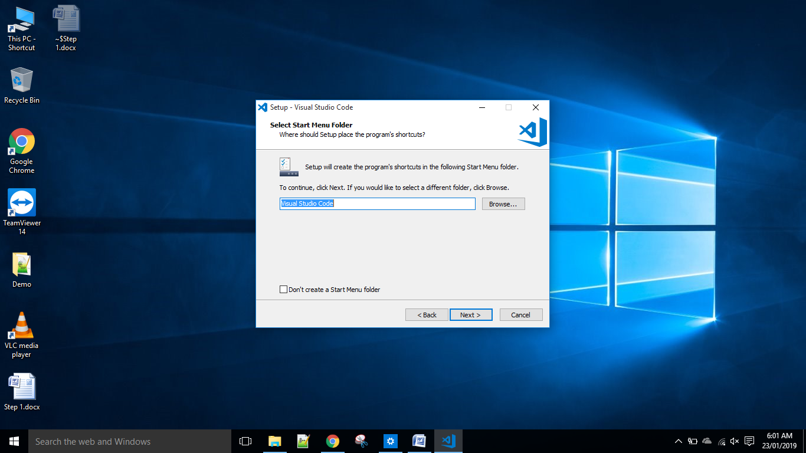

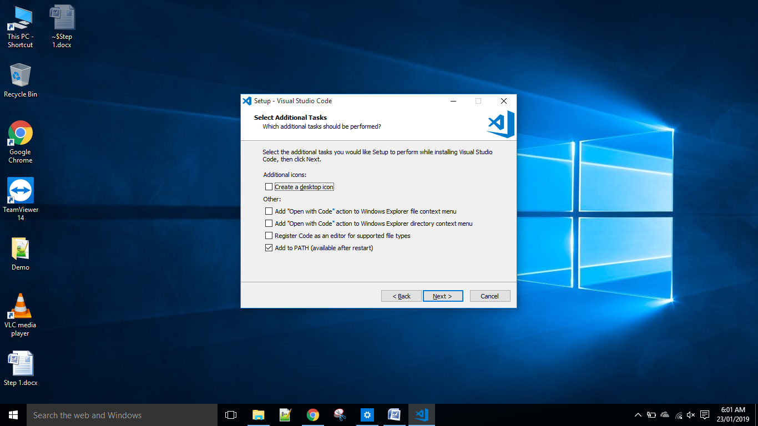

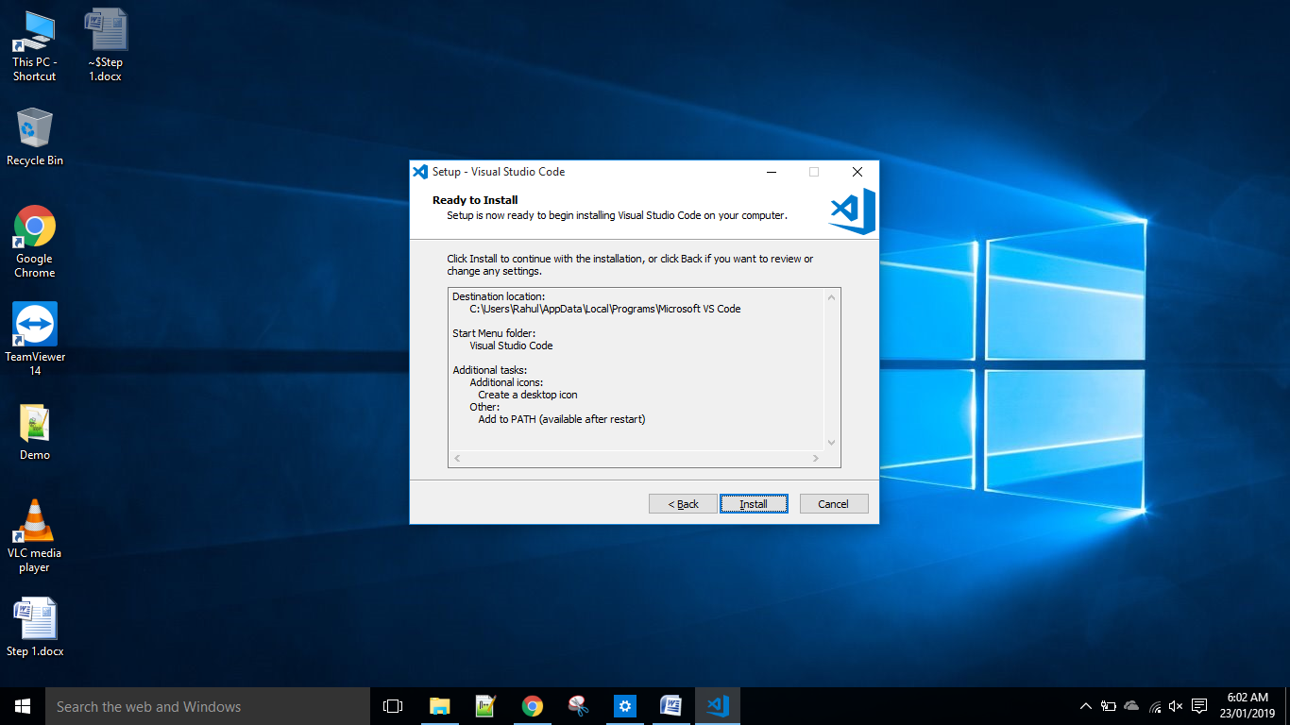

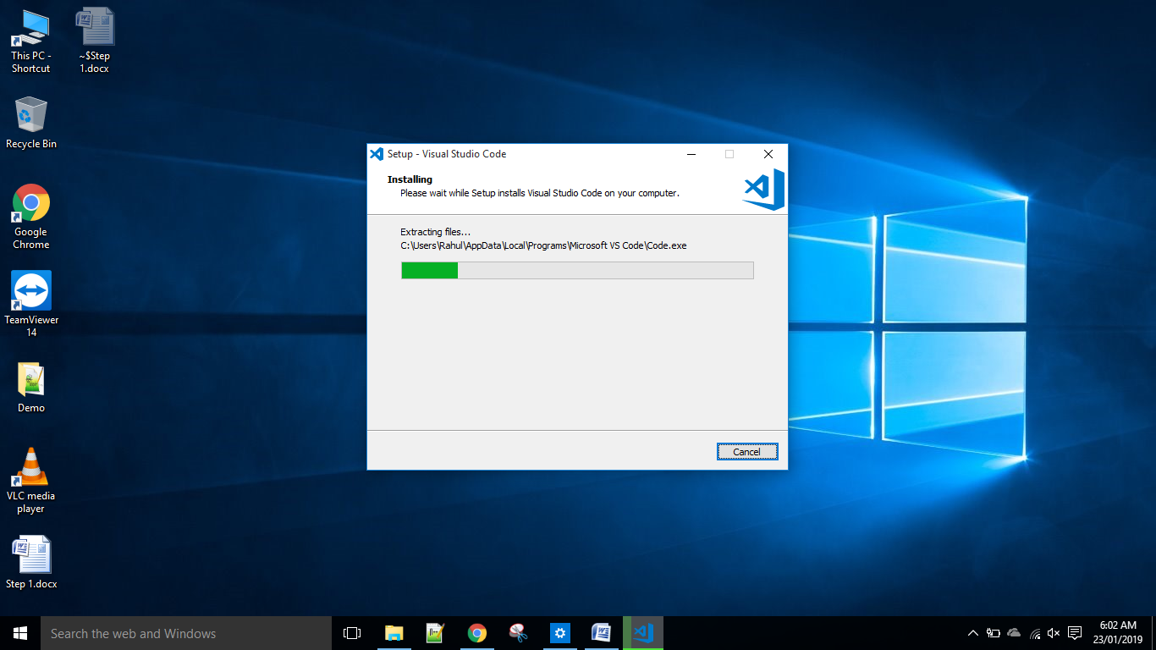

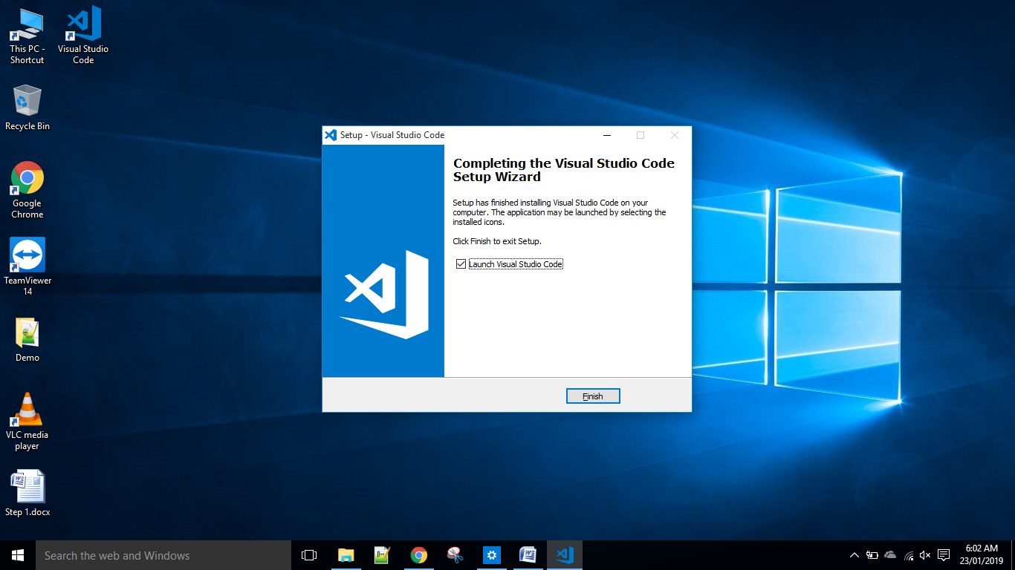

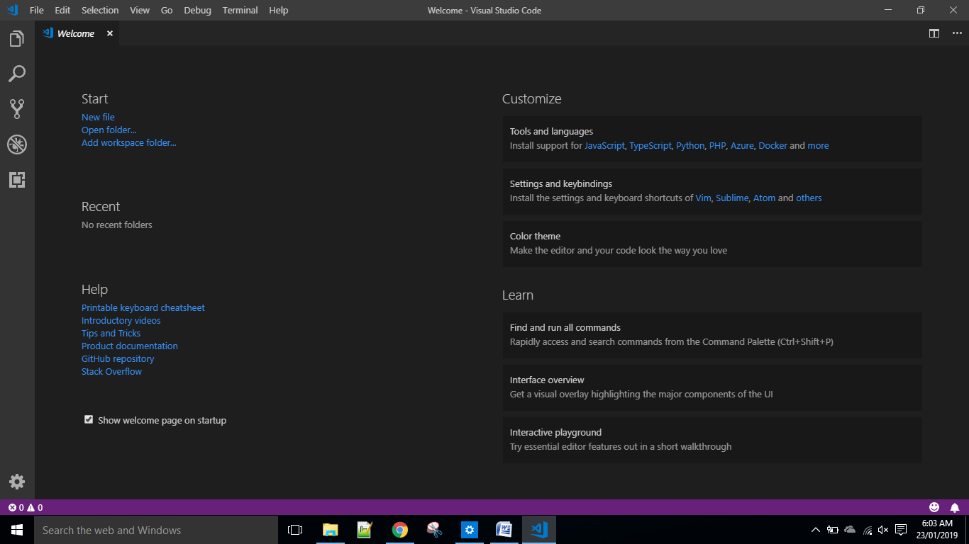

* Make sure you have the latest Visual code studio(1.26.2 or later) installed on your machine. Otherwise you may not be able to install the Salesforce CLI and Salesforce Extension Plugin.

Step 2 : Install the Salesforce CLI Program.

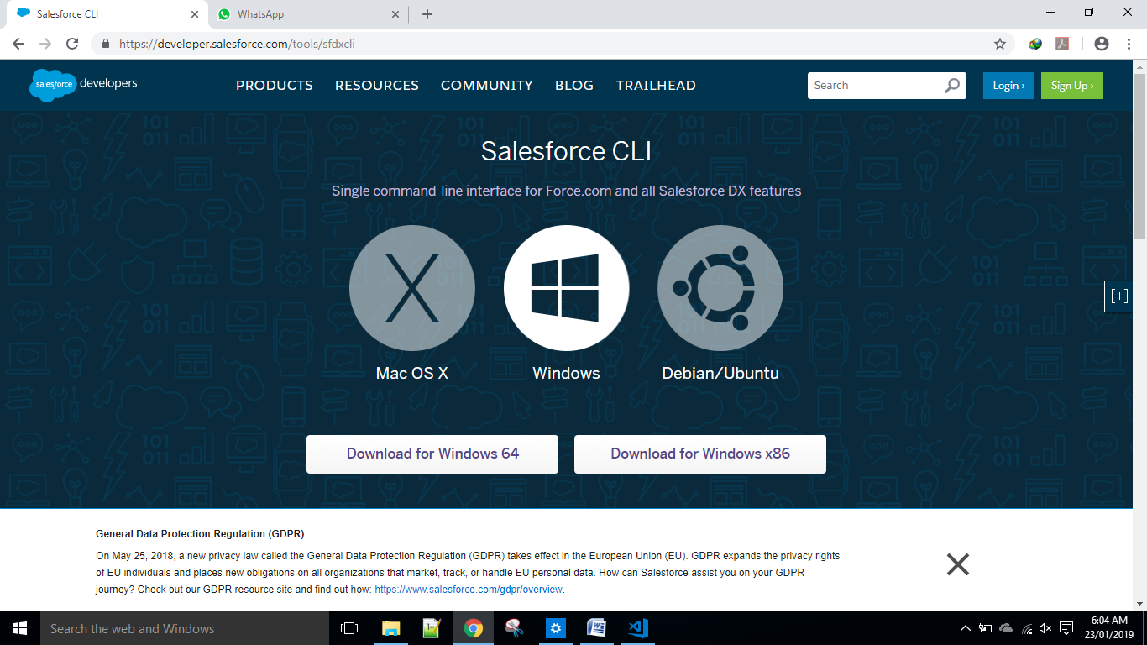

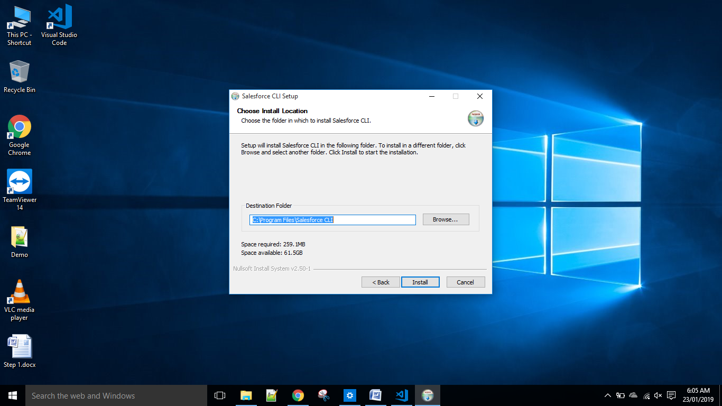

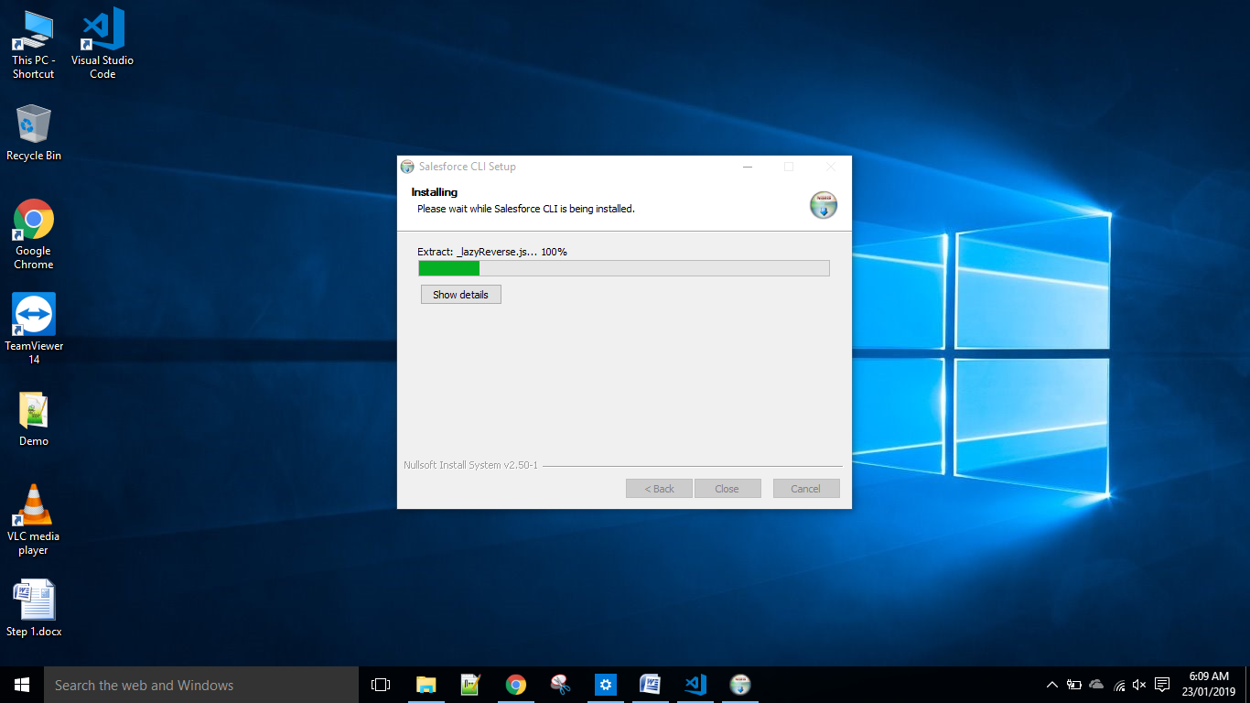

Step 3 : Make sure the following commands are working.

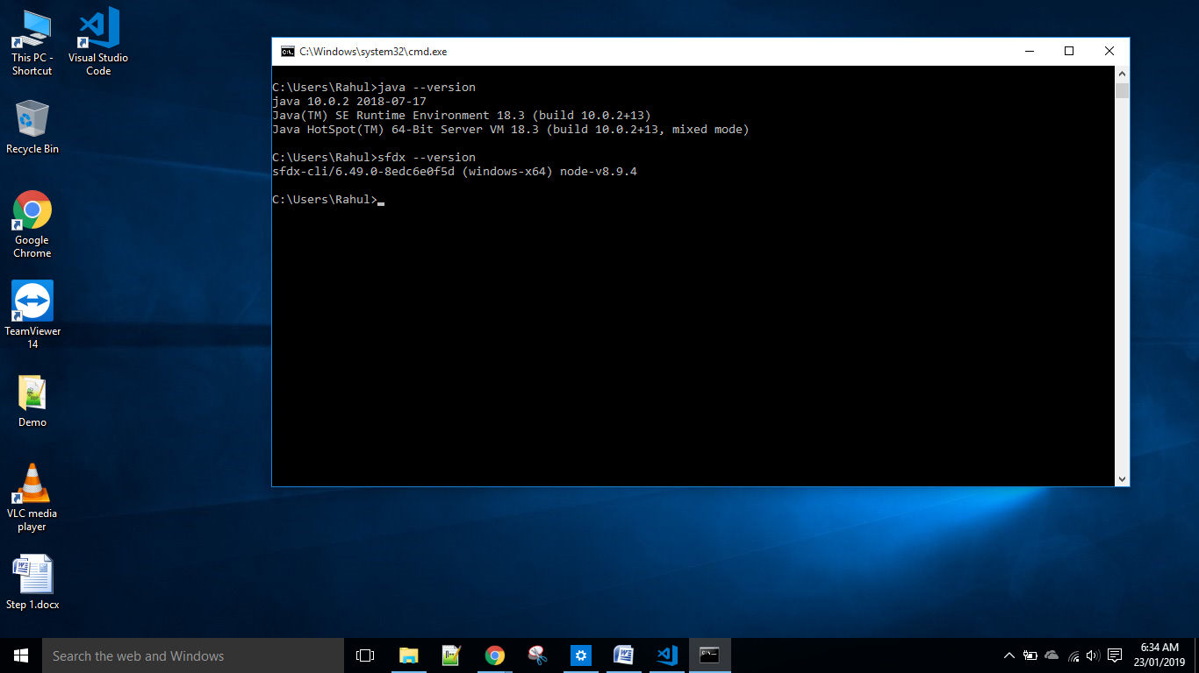

Step 4 : Install Salesforce CLI Extension in Visual studio code.

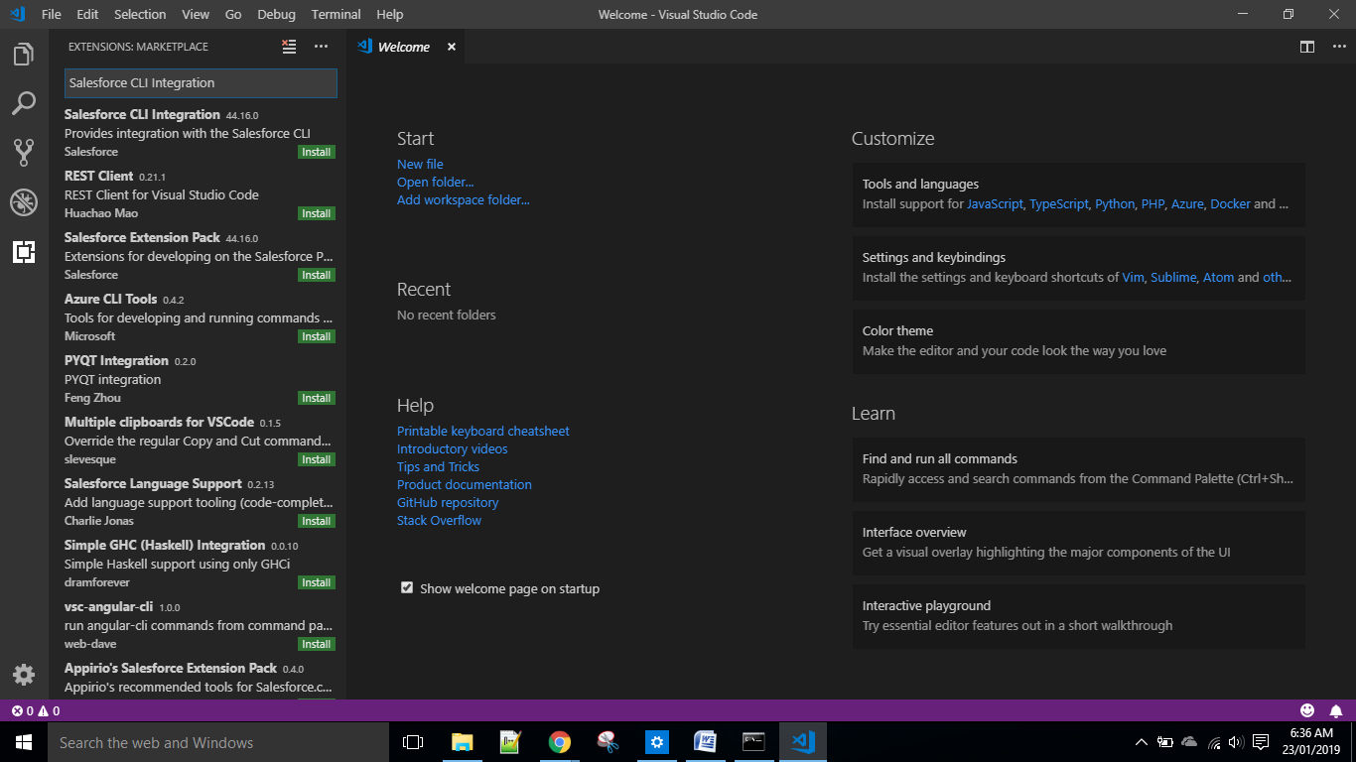

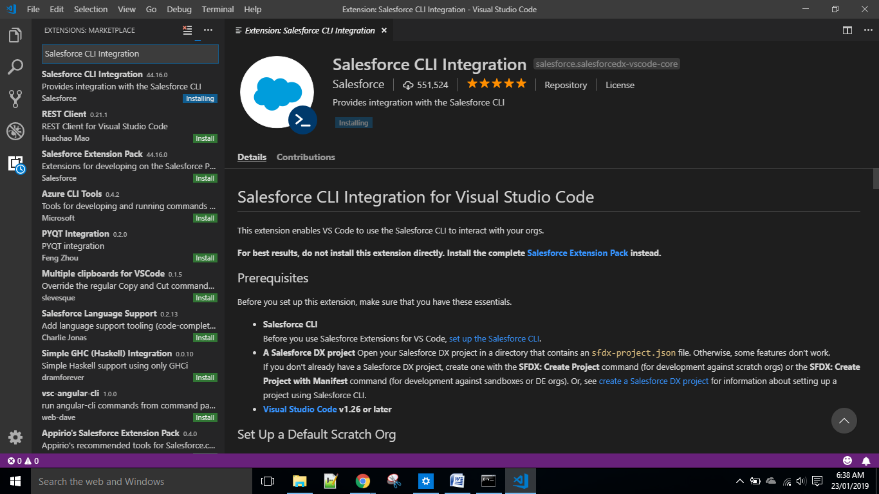

* If Unable to install by clicking on install button, just Download the vslx extension file mannualy and install it using simple command prompt by hitting following command on cmd.
* code --install-extension <complete path of the downloaded file from your local machine>.
* After Plugin Installation don’t forget to reload using reload button.

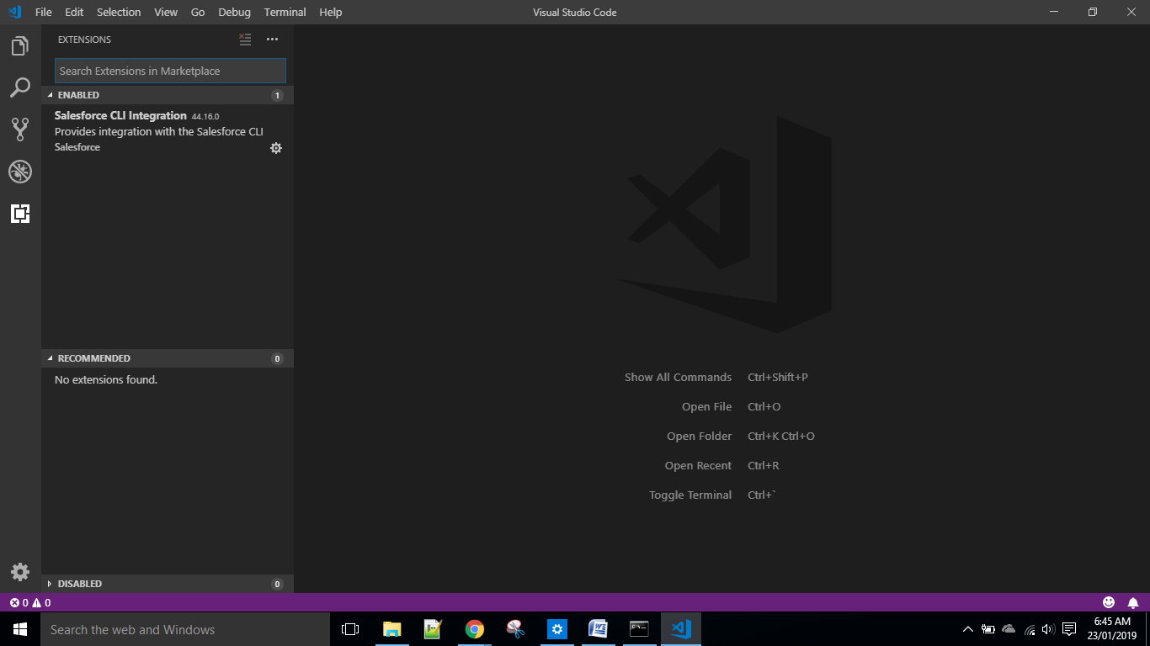

Step 5 : Install Salesforce Extension pack using visual studio code program as below.

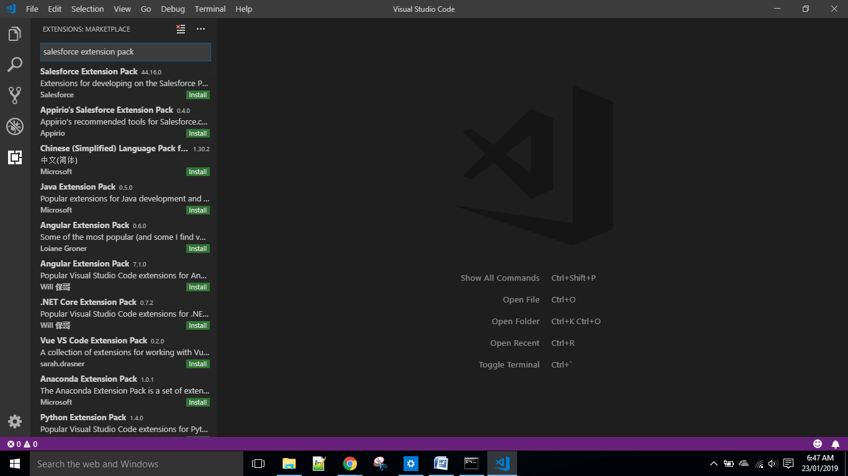

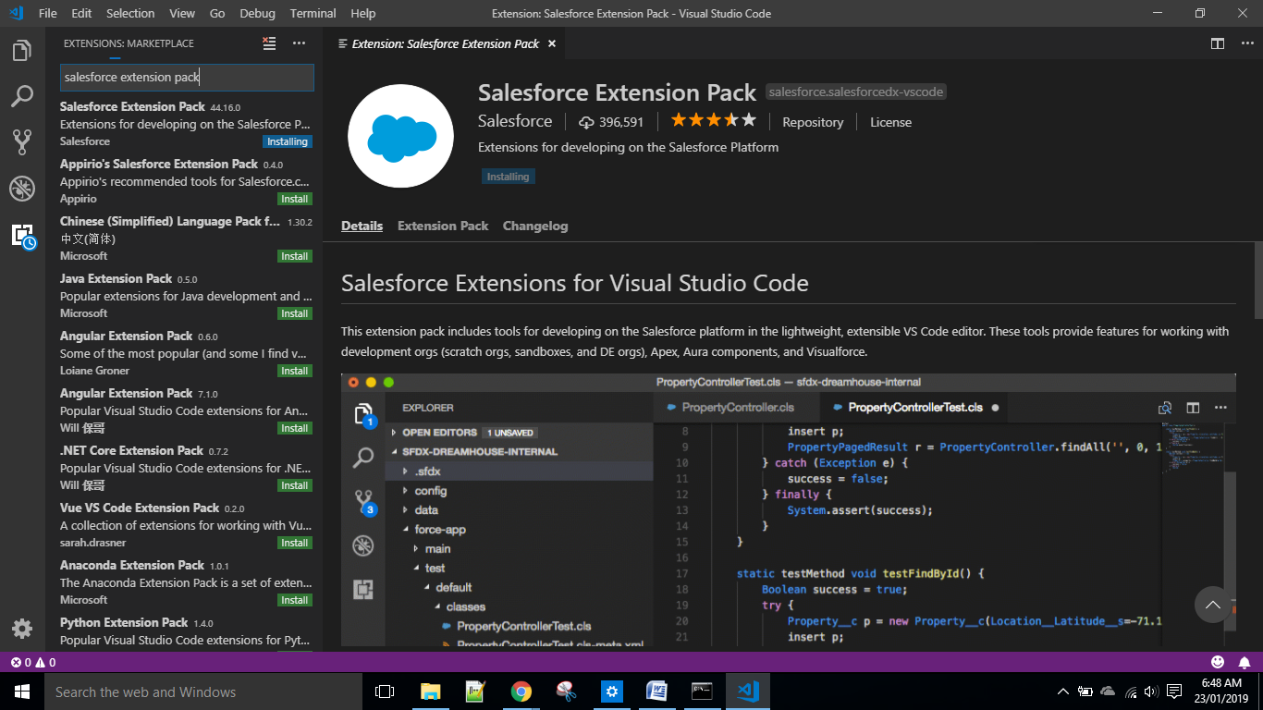

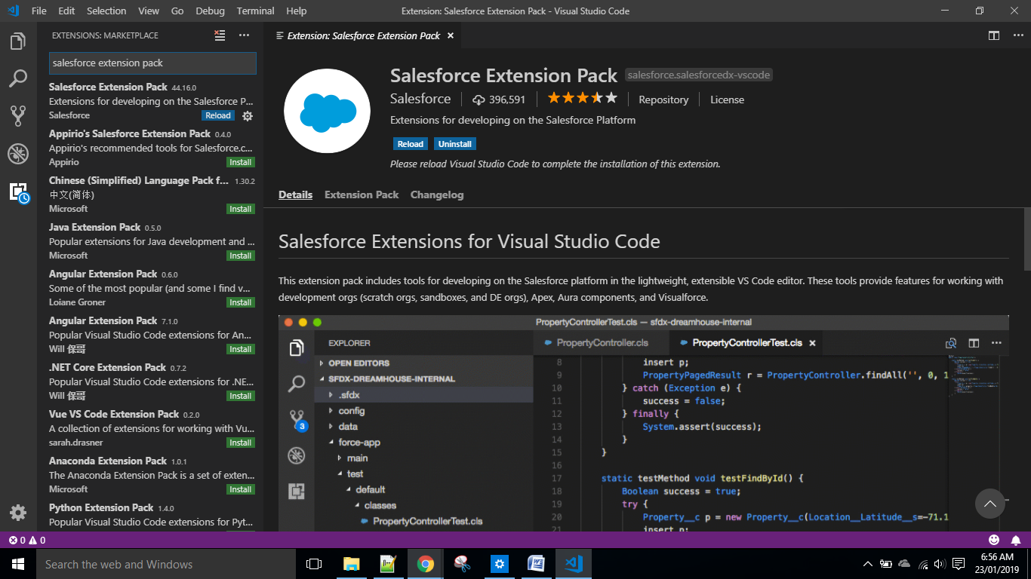

* Click on reload button and restart the Visual studio code.

Step 6 : Open Command Palate using shortcut ctrl+shift+p and type sfdx there. We can see all the commands that we can use against salesforce.

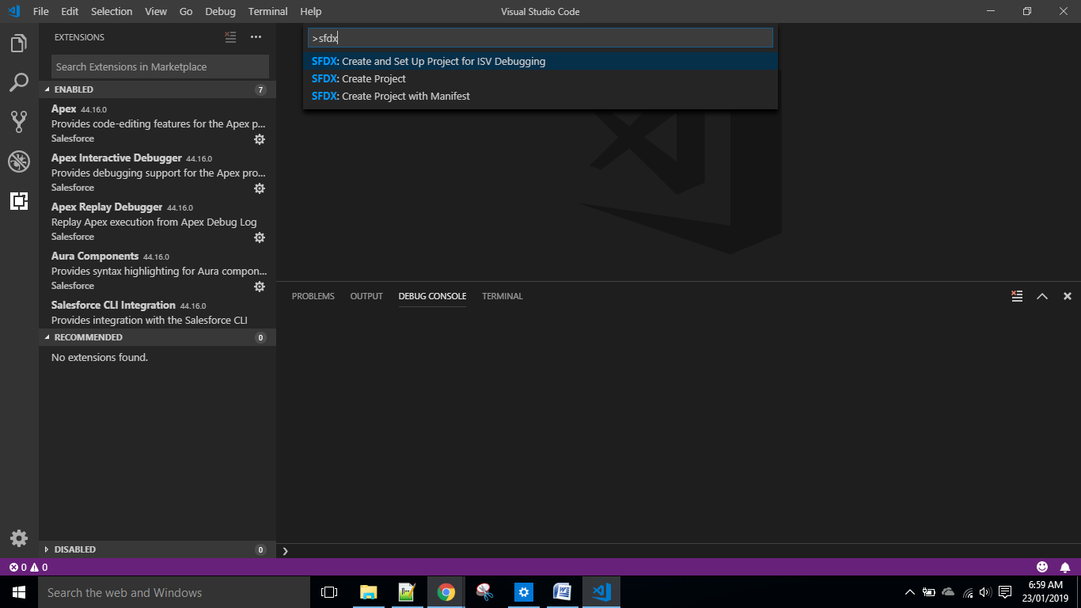

Step 7 : Create local repository .

* Click on SFDX: Create Project with Manifest.
* Enter the name of the Project.

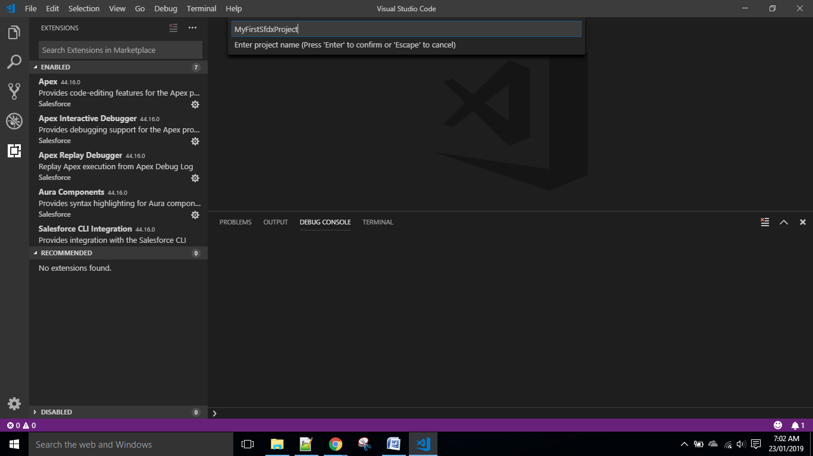

* Choose your location on your machine and click on create project.

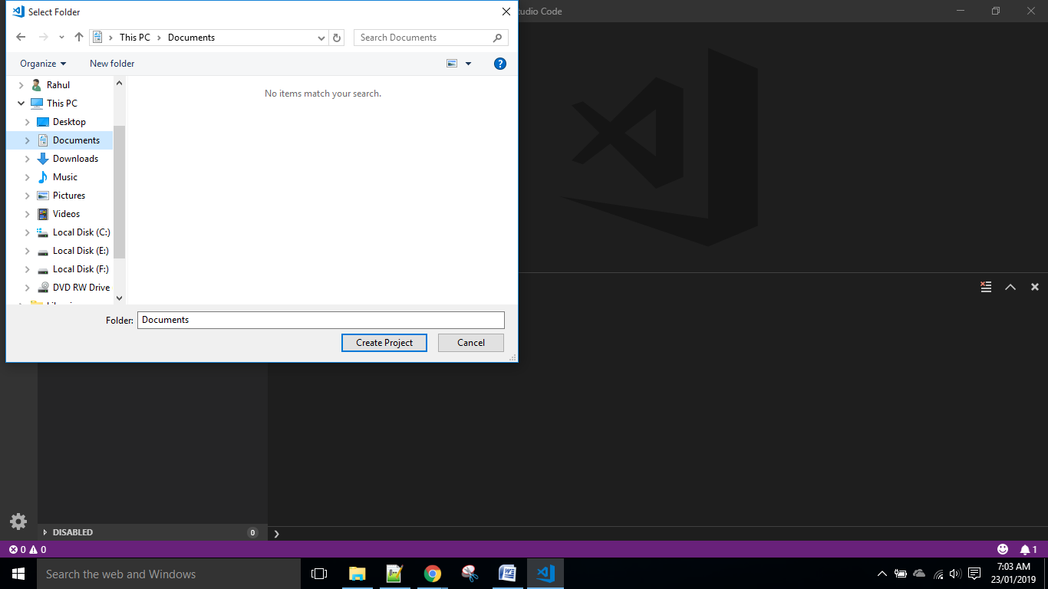

* Now sfdx started running using Salesforce CLI Integration that we have installed in step 2.

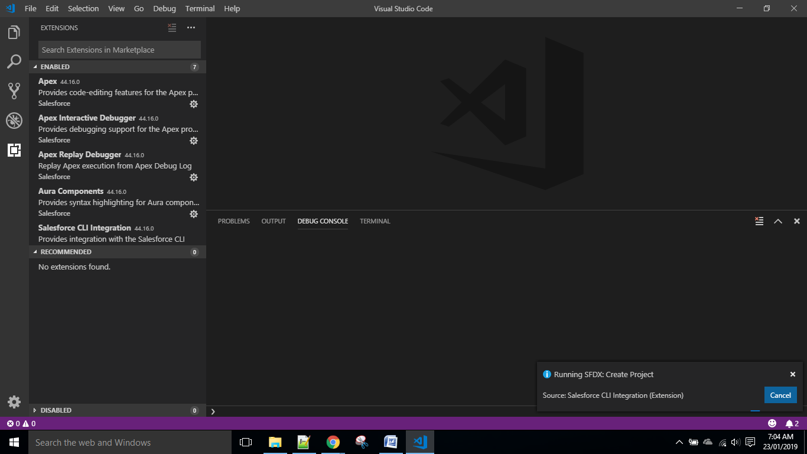

* Wait for a while. The waiting time will depend on your System configuration.

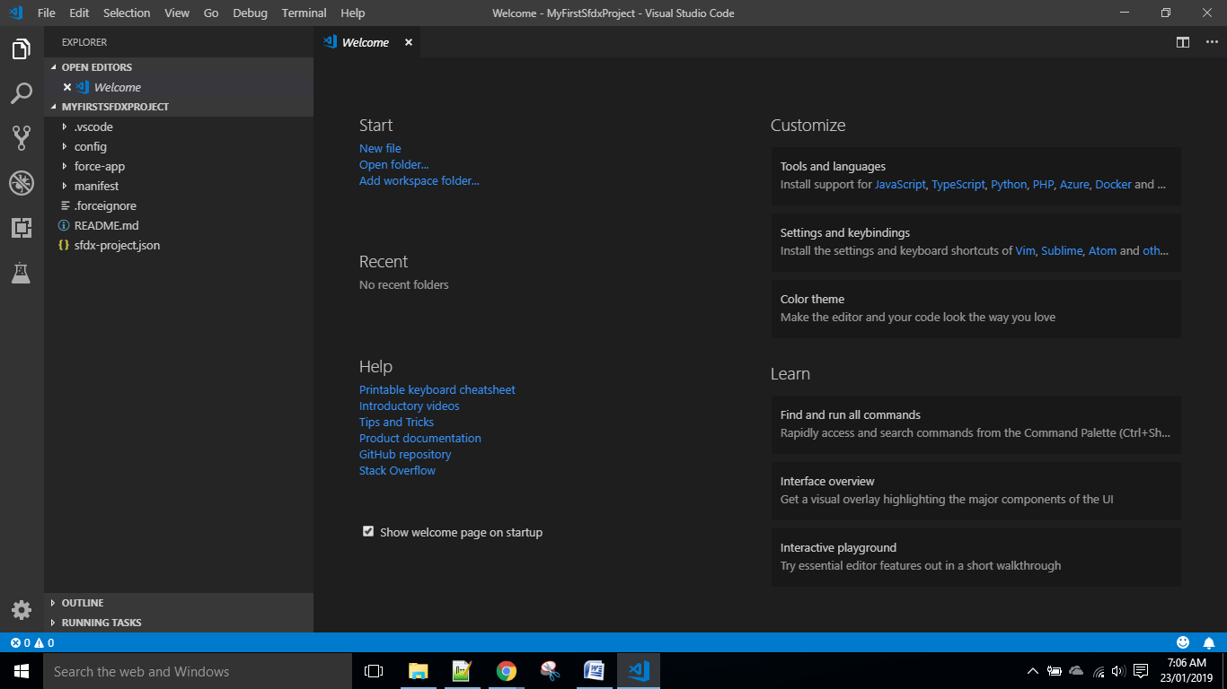

* Local Repository Creattion finished.

Step 8 : Connecting an org using dev hub Configuration or using Credential approach.

* Go to set up in your salesforce org and type dev hub.

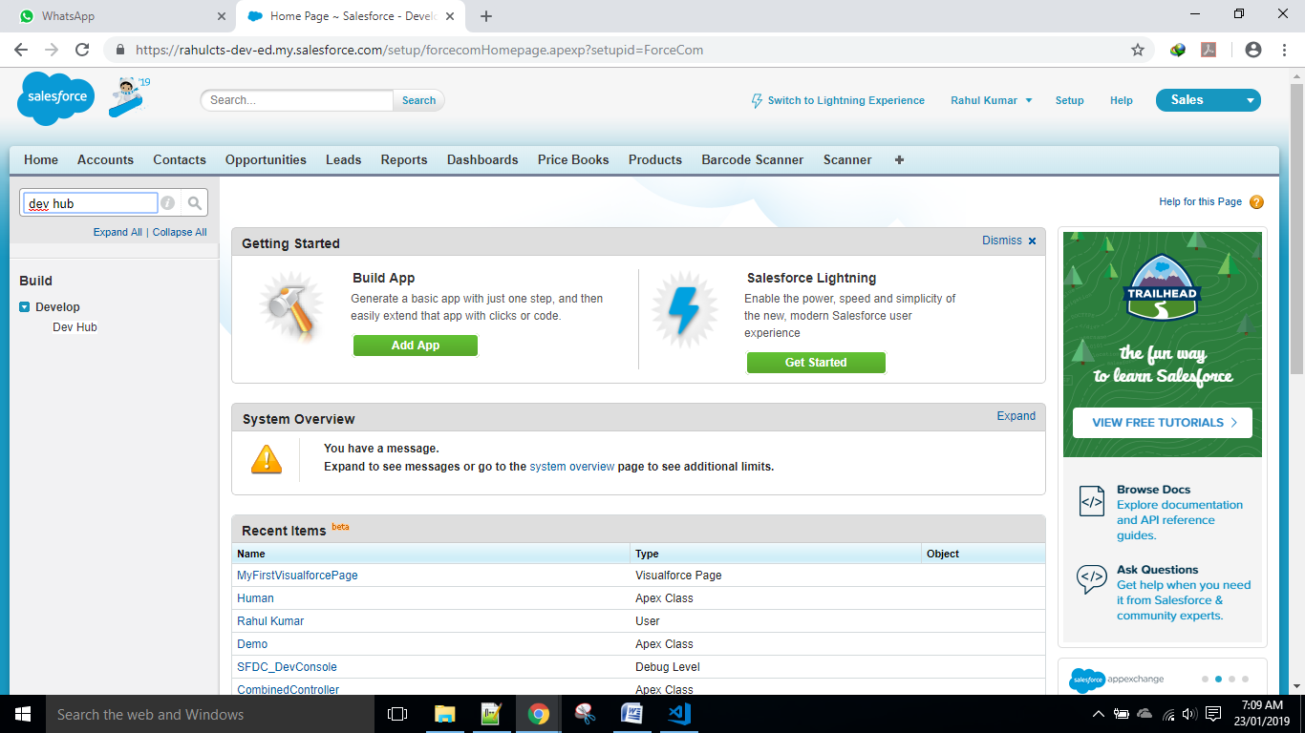

* Enable it. Once it’s been enabled, can’t be disabled again.

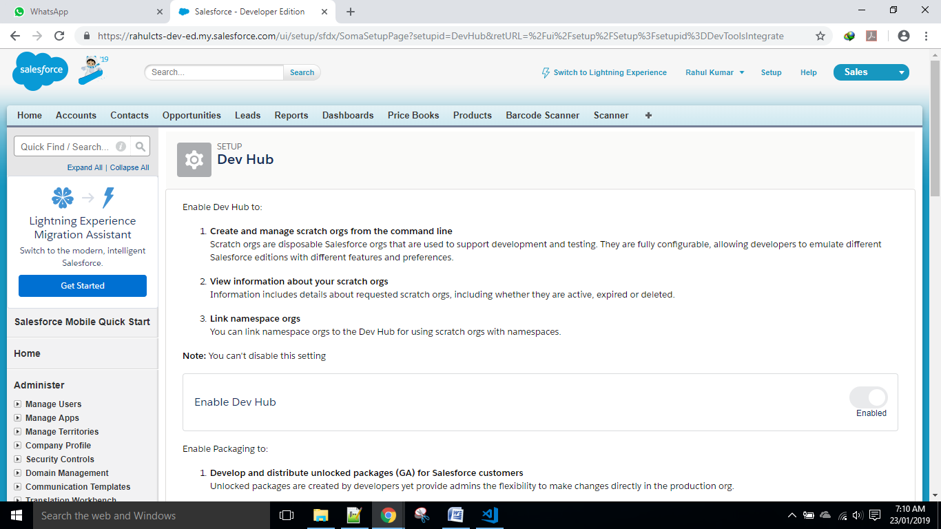

* Go to Visual studio code and open the command palate.
* Type the command : >SFDX: Authorize a Dev Hub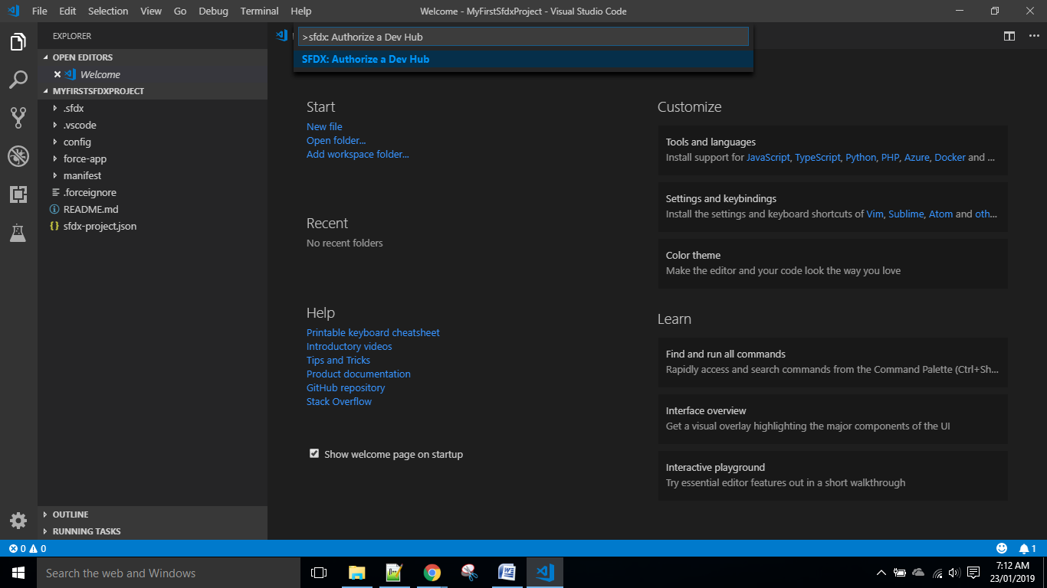

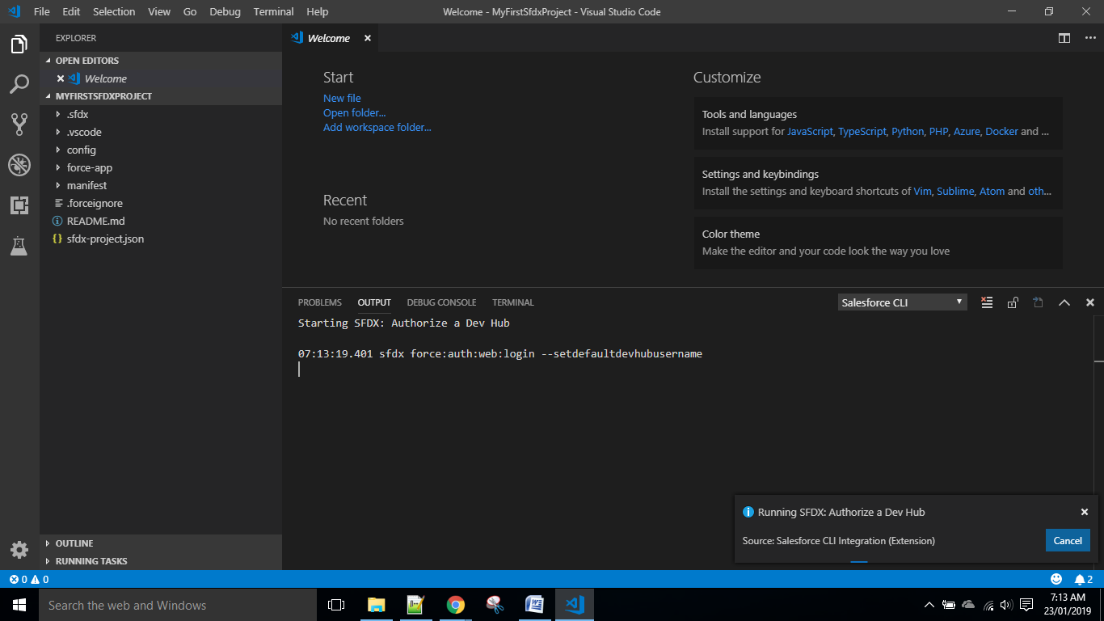

* This will take you to the login page on your existing browser.

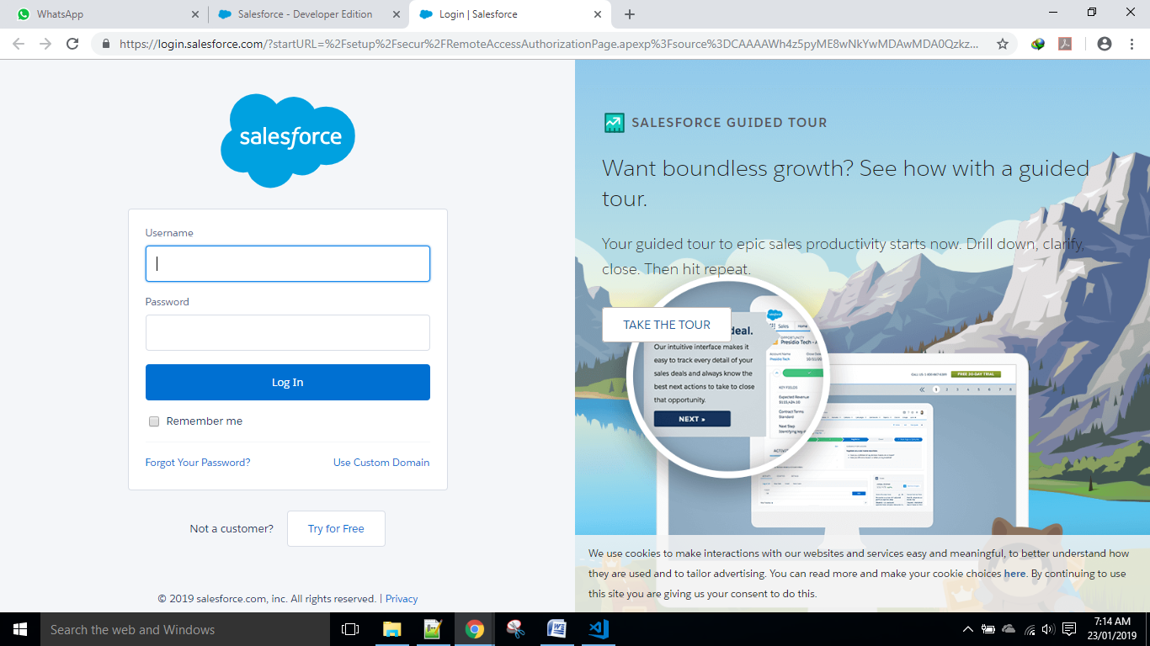

* This will ask for granting the permission. Allow it.

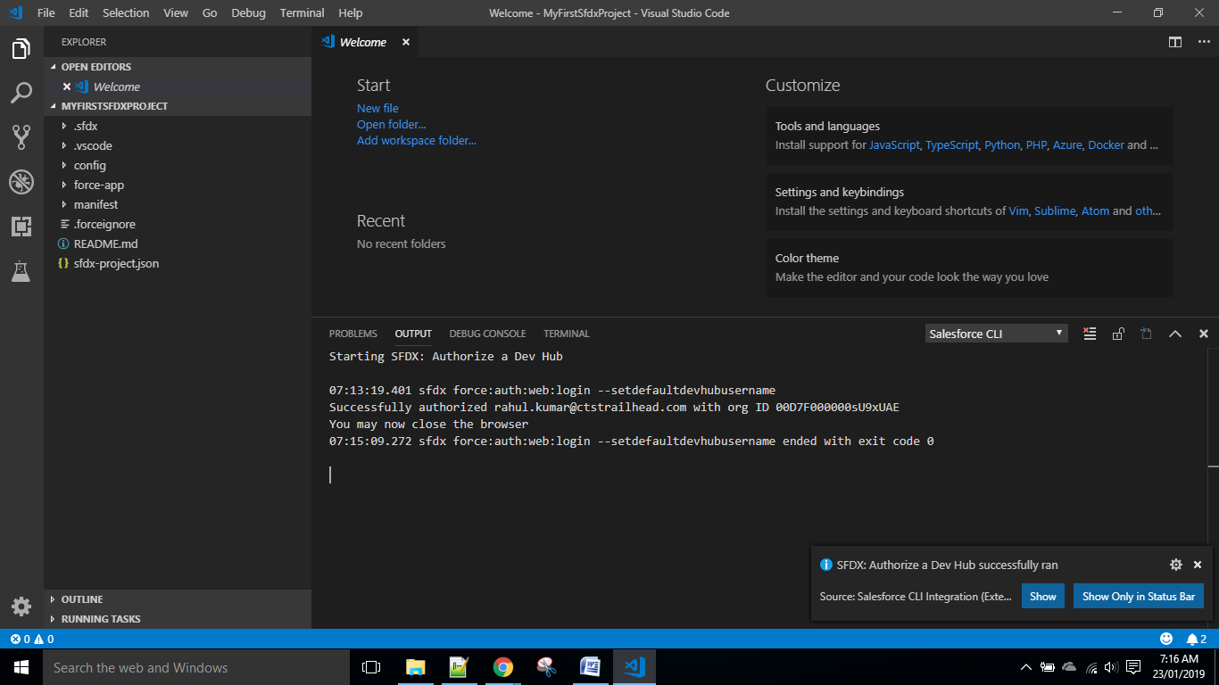

* Org successfully got connected.

Step 9 : Some Example of Visualforce page and Controller Class and Using it.

* Right Click on force-App and Click as in the image.

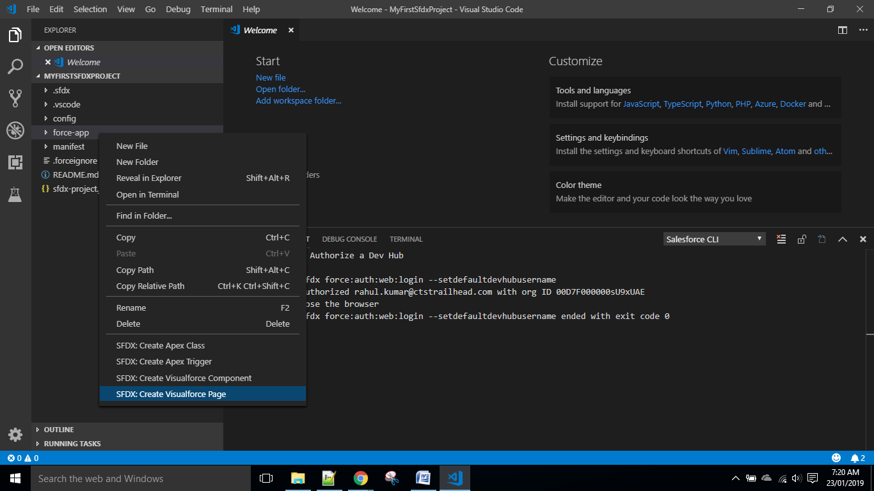

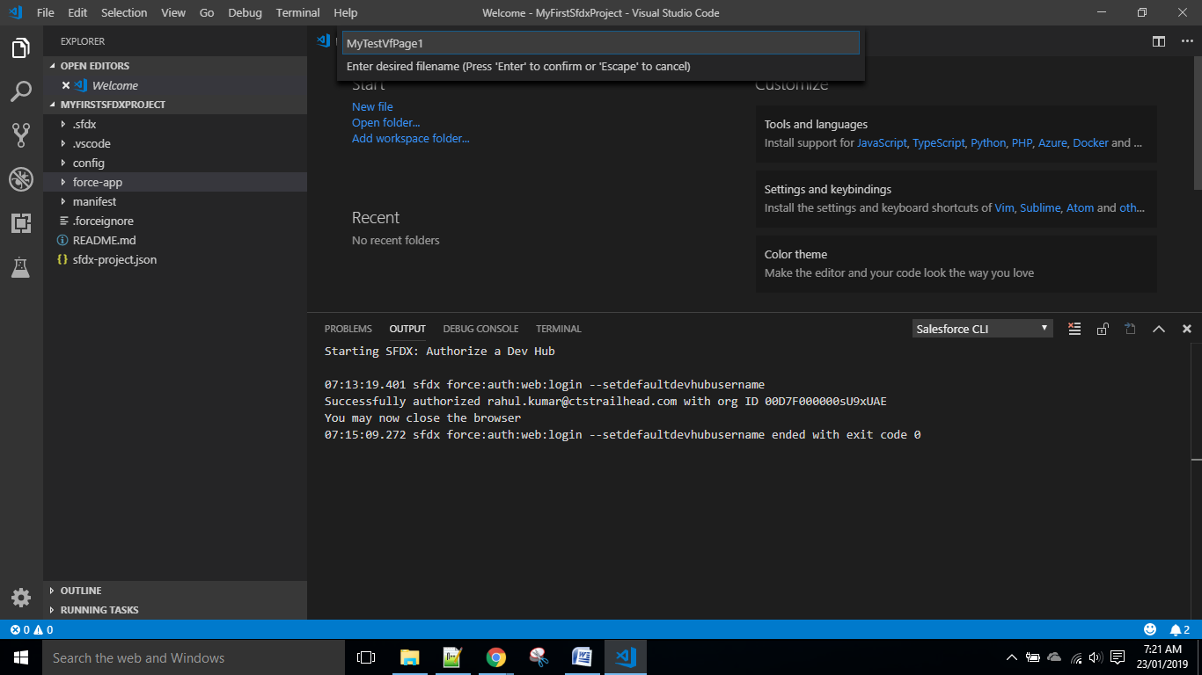

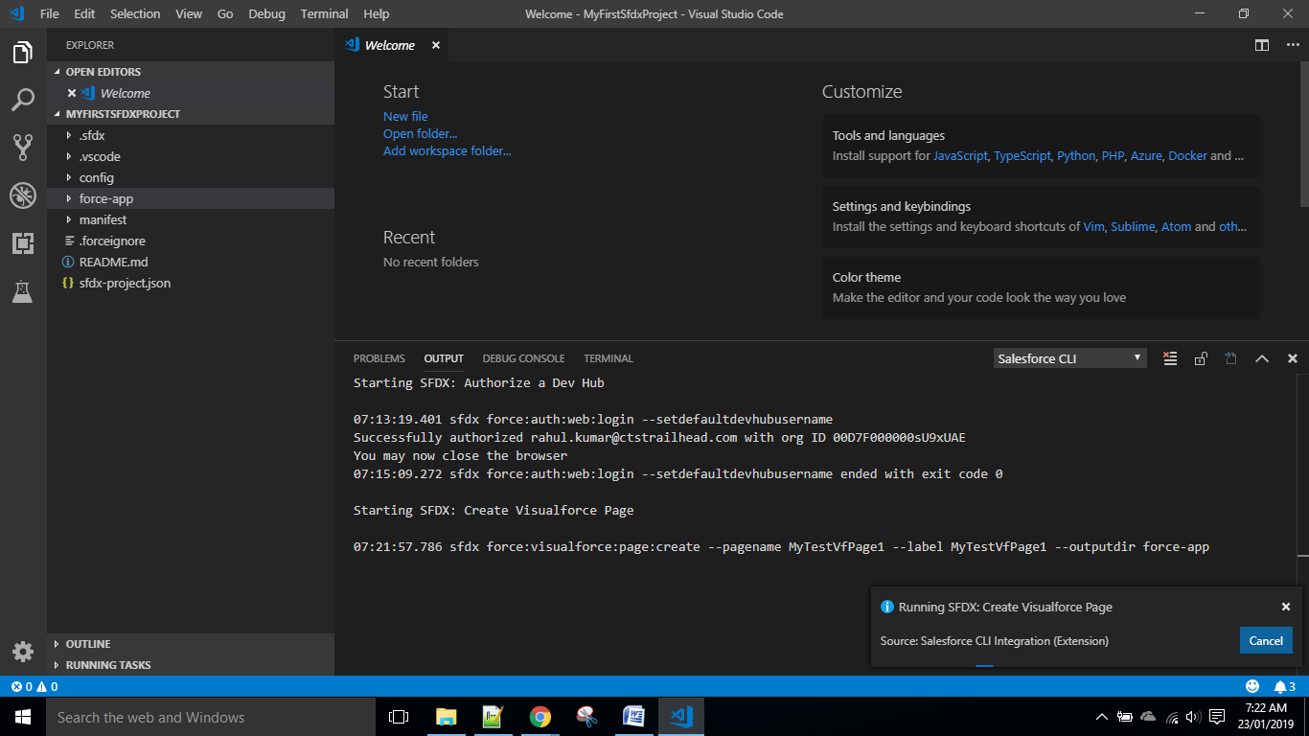

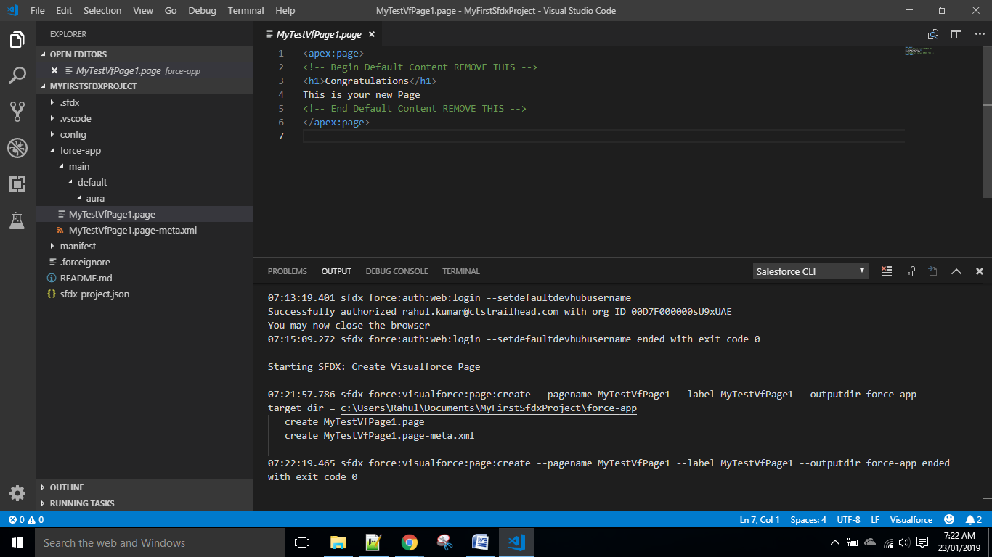

* Before Deploying codes to your org ,set the default org by writing the below commands on the Terminal console.

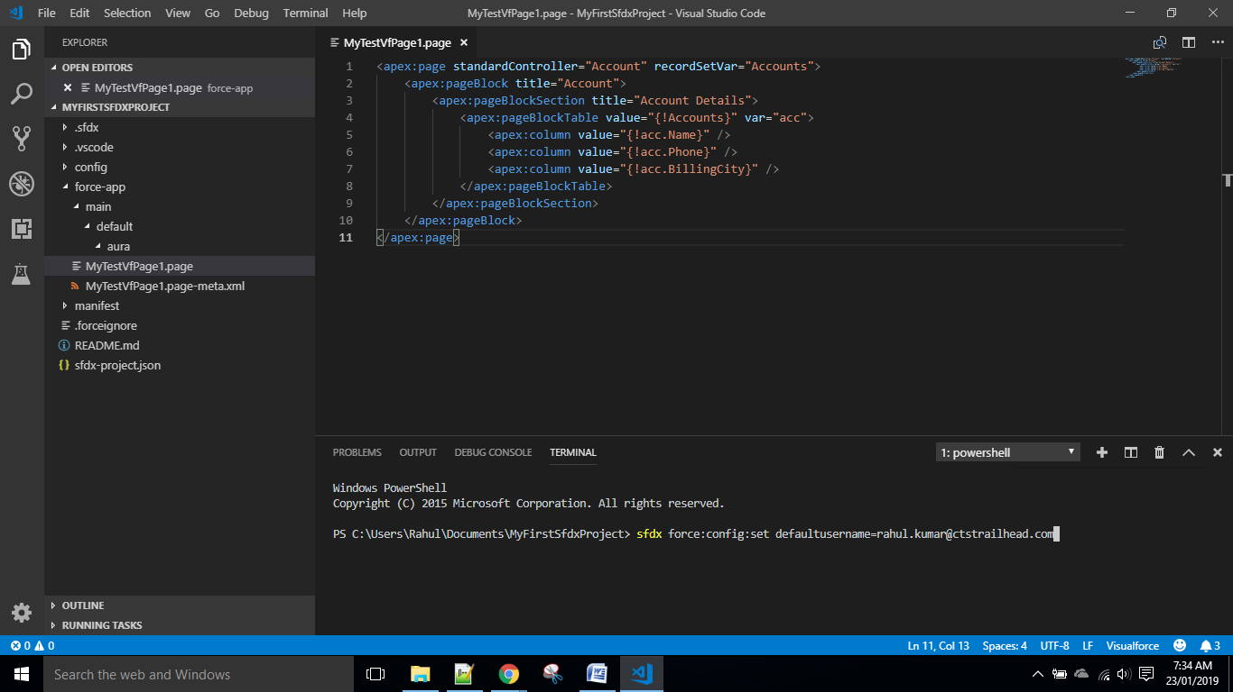

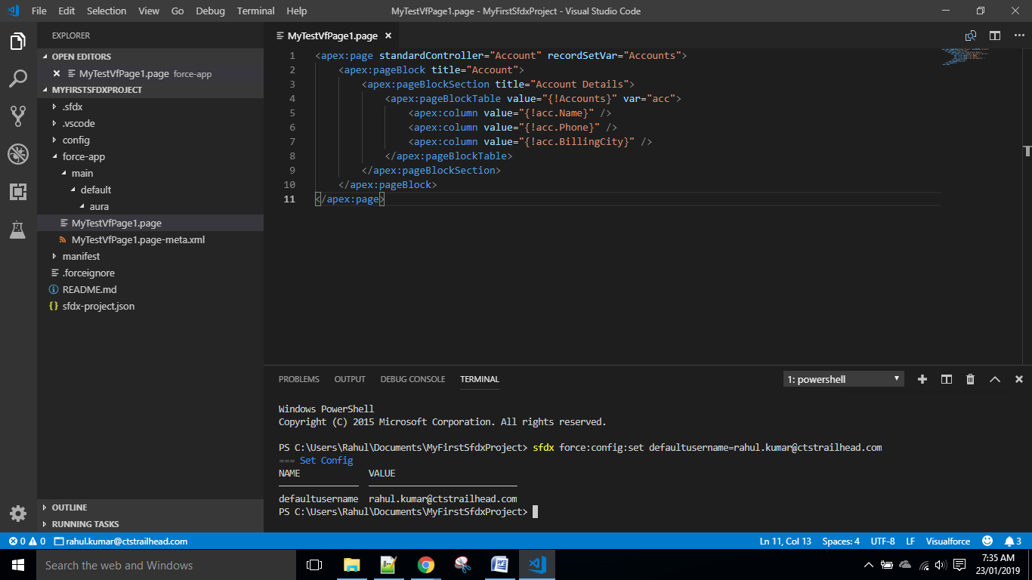

* Right Click on vf page and click on the below option.

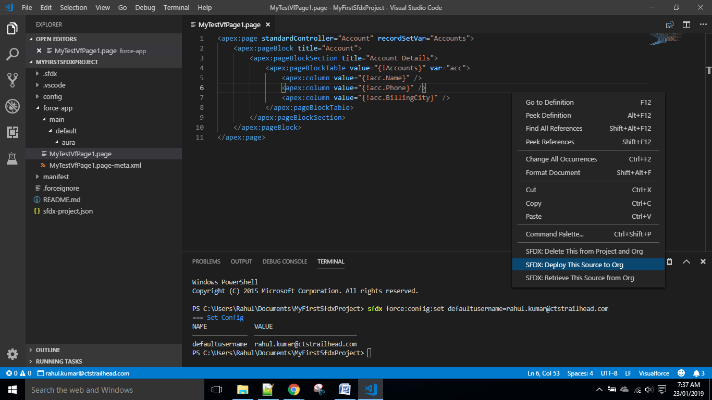

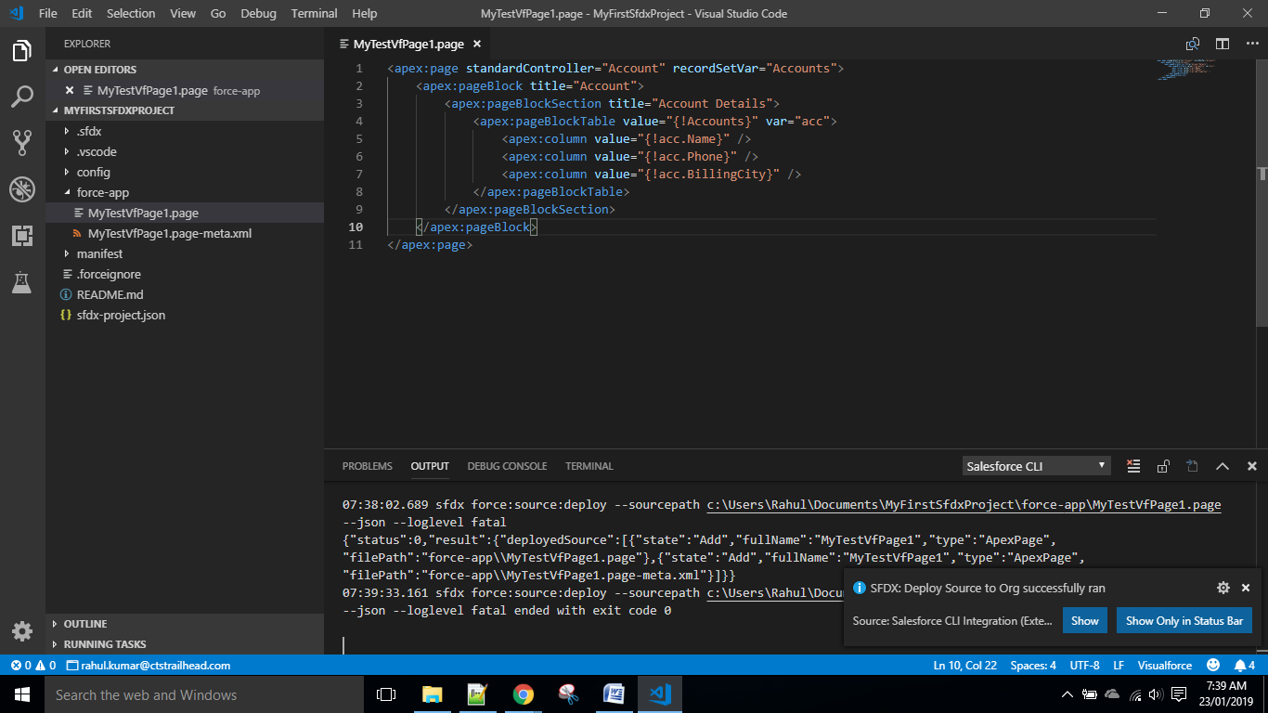

* Go inside the Org and Try to Open the vf page by hitting end-url as /apex/vf_page_name

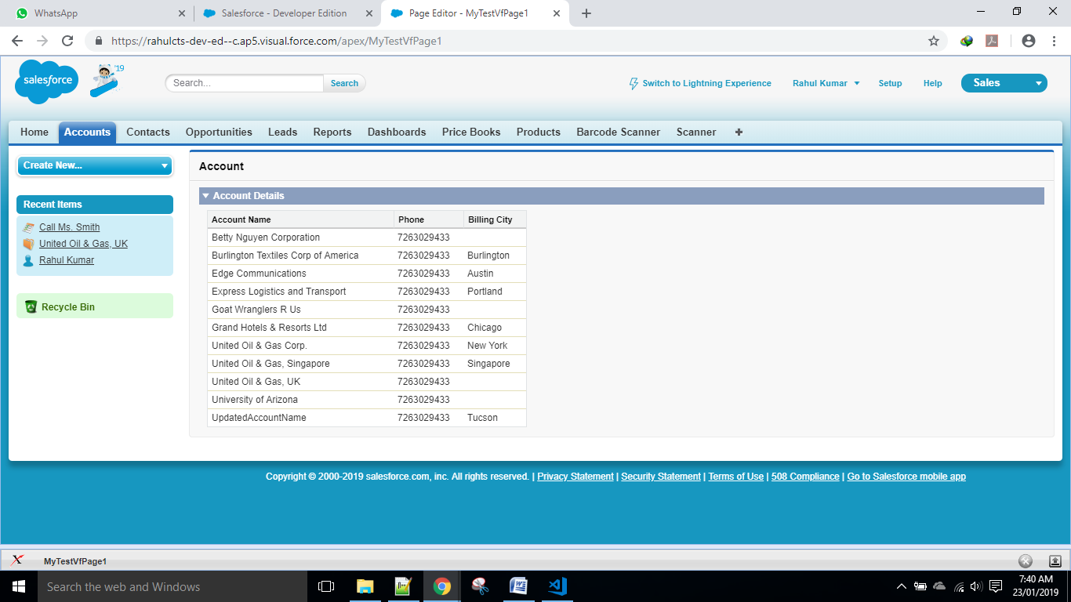

* Output can be seen.

Step 10 : Installation of JEDI & PMD Plugin.

* Download and Install the plugins from Chatter and follow the installation and set up process using the documentation provided there.

**Thank You!**

**Rahul Kumar (590455)**

**(Programmer Analyst)**

**Cognizant Technology Solutions.**